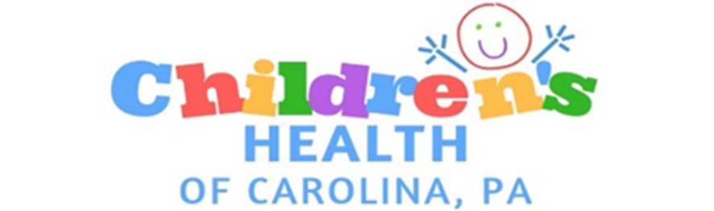

Children’s Health of Carolina, PA

HIPAA Consent Form

I understand that as part of my healthcare, Children’s Health of Carolina, PA (Children’s Health Lumberton, Children’s Health Pembroke, Children’s Health Raeford, Children’s Health Fayetteville, and Children’s Health Fairmont) originates and maintain health records describing my child’s/children’s health history, symptoms, examination, test results, diagnoses and treatment plans (including referrals and future appointments). By signing this form, I am consenting to Children’s Health of Carolina, PA to use and disclose my child’s/children’s health information to carry out treatment, payment and healthcare operations (TPO). I further understand this information serves as:

* A basis for planning my child’s/children’s care and treatment;
* A means of communication among the many healthcare professionals who contribute to my child’s/children’s care;
* A source of information for applying my child’s/children’s diagnoses to a bill;
* A means by which a third party payer can verify that services were actually provided;
* A tool for routine healthcare operations such as assessing quality and reviewing the competence of healthcare professions.

With this consent, Children’s Health of Carolina, PA may call my home or other designated locations provider by me as legal guardian and leave a message on voice mail or in person, FAX, or email me in reference to any items that assist the practice in carrying out my child’s/children’s TPO.

I understand and have been provided an opportunity to review the corporate HIPAA notice. I further understand that the corporation reserves the right to change the notice at any time, with the changes being posted in our reception areas. I also understand that I have the right to modify or revoke this consent form at any time, except to the extent that Children’s Health of Carolina, PA has already taken action in reliance thereon.

I authorize Children’s health of Carolina to communicate my protected in the following methods:

____ Leave detailed message on my home telephone answering machine

____ Leave detailed message on my office telephone answering machine

____ Leave detailed message on my cell telephone answering machine

____ Leave detailed message on my FAX

____ Email detailed medical information

I hereby give permission to the following person(s) listed below to receive information about the care of my child/children:

Name Relationship

_______________________________ _____________________________

_______________________________ _____________________________

_______________________________ _____________________________

_______________________________ _____________________________

_______________________________ _____________________________

_______________________________ _____________________________

In order to obtain information by telephone, the party calling must provider the practice with the patient’s date of birth. With the exception of parents or legal guardians, if the party is not on the list, the staff will be unable to share any information regarding the patient.

_________________________________ ______________________

Printed full name of child Child’s Date of Birth

_________________________________ ______________________

Printed full name of child Child’s Date of Birth

_________________________________ ______________________

Printed full name of child Child’s Date of Birth

_________________________________ ______________________

Printed full name of child Child’s Date of Birth

_________________________________ ______________________

Printed full name of child Child’s Date of Birth

I have read, understood and agree with the terms of this consent. I further acknowledge that I can legally represent the child/children listed on this document.

_______________________________________

Printed name of the parent/legal guardian

_______________________________________

Signature of parent/legal guardian

_______________________________________

Printed Staff’s Name